**Cloud-Enabled Automatic Number Plate Recognition System with ESP32-CAM for Smart Surveillance Applications**

Ritesh Mohanty, Jyotismita Nath, Satyajit Sahu, Ankit Kumar

Centre for Internet of Things, Computer Science Engineering, Siksha ‘O’ Anusandhan Deemed to be University, Bhubaneswar 751030, India

### **Abstract**

### The demand for intelligent surveillance systems is growing as societies seek enhanced security, improved monitoring, and efficient management of resources. In this context, the integration of Internet of Things (IoT) technologies with computer vision provides a transformative solution. This project introduces a cloud-enabled Automatic Number Plate Recognition (ANPR) system designed using the ESP32-CAM module, specifically targeting smart surveillance applications. The ESP32-CAM, a compact and cost-efficient device, is utilized for image capture and preliminary processing at the edge. The system employs optical character recognition (OCR) algorithms to accurately extract vehicle number plate information, even under varying environmental and lighting conditions. To augment its capabilities, the system leverages cloud computing for real-time data storage, analysis, and accessibility. The cloud platform not only ensures scalability to handle a large volume of data but also supports remote access, enabling monitoring and management from virtually anywhere. Additionally, the integration with cloud-based data analytics enhances the system's utility for applications such as traffic management, parking enforcement, and security surveillance. By bridging the gap between edge processing and cloud intelligence, the proposed system achieves a balance of performance, affordability, and versatility, making it an ideal solution for modern surveillance needs. This project demonstrates how IoT and computer vision technologies can collaborate to create a powerful and efficient surveillance system tailored to real-world challenges.

1. Introduction

In the rapidly advancing field of surveillance technologies, Automatic Number Plate Recognition (ANPR) systems have become essential tools for improving traffic management, law enforcement, and security monitoring. These systems automate the detection and identification of vehicles, significantly reducing the need for manual intervention while enhancing the accuracy and operational efficiency of surveillance activities. The incorporation of cloud computing into ANPR systems further amplifies their capabilities, enabling real-time data processing, seamless remote accessibility, and scalable storage solutions. This combination of technologies aligns with the growing demands of smart cities and IoT-driven applications, addressing modern challenges in surveillance and urban management.

This project introduces a **Cloud-Enabled Automatic Number Plate Recognition System** utilizing the versatile ESP32-CAM module. The ESP32-CAM is a low-cost microcontroller equipped with built-in camera capabilities, making it an ideal platform for edge-based image capture and preliminary processing. Despite its compact size and affordability, the ESP32-CAM is powerful enough to perform essential tasks such as capturing high-resolution images and performing local computations, which minimizes the latency associated with data transfer to the cloud. By integrating this module with advanced cloud computing technologies, the system provides a robust framework for data management, analytics, and interoperability with other smart systems.

One of the core features of this project is its ability to perform **real-time vehicle detection and identification** using optical character recognition (OCR). This functionality enables the system to decode license plates accurately, even in varying environmental and lighting conditions. The captured vehicle data is transmitted to a cloud-based database, where it is stored securely and can be retrieved as needed for further analysis or reporting. This approach ensures that the system can handle large volumes of data efficiently, catering to the demands of high-traffic environments such as highways, parking lots, and restricted zones.

The cloud integration not only supports data storage but also enables advanced analytics, such as trend analysis, anomaly detection, and predictive insights. For example, the system can analyse traffic patterns to optimize traffic flow or detect unauthorized vehicles entering restricted areas. The cloud platform also facilitates remote accessibility, allowing users to monitor and control the system from any location via web or mobile applications. This feature is particularly beneficial for decentralized or large-scale deployments, such as city-wide surveillance networks.

The proposed system is designed for a wide range of applications. In **traffic management**, it can be used for automated toll collection, congestion monitoring, and enforcement of traffic rules. In **parking management**, it enables automated entry and exit logging, fee calculation, and space optimization. For **security purposes**, the system can monitor restricted areas, track suspect vehicles, and provide real-time alerts for law enforcement. These capabilities make it a valuable tool for enhancing security and operational efficiency across various sectors.

By combining cutting-edge hardware like the ESP32-CAM with the power of cloud technologies, this project offers a scalable, efficient, and user-friendly solution to modern surveillance challenges. It addresses the needs of smart cities by integrating IoT-driven solutions into critical infrastructure, paving the way for more intelligent and responsive systems. Furthermore, the system's affordability and modular design make it accessible to a wide range of users, from government agencies to private enterprises, ensuring its relevance and impact in diverse applications.

1. System Architecture

The Loud-Enabled Automatic Number Plate Recognition (ANPR) System with ESP32-CAM for Smart Surveillance Applications is an advanced surveillance solution that integrates image processing, machine learning, and communication technologies for real-time vehicle monitoring and number plate recognition. The system architecture is designed around several key components, working in tandem to capture, process, and analyze images of vehicle number plates autonomously.

At the heart of the system is the ESP32-CAM module, a low-cost, high-performance microcontroller equipped with a camera and built-in Wi-Fi capabilities. This module captures images of vehicles passing through the camera's field of view. The ESP32-CAM’s camera is responsible for capturing high-resolution images of vehicle license plates, which are then sent for processing. The Camera interfaces with the ESP32-CAM, which controls image capture and subsequent communication with other modules.

The captured images are processed in real-time using Image Processing Algorithms that extract the license plate number from the photo. These algorithms may utilize Optical Character Recognition (OCR) technology, which is capable of identifying and converting the text on the license plate into machine-readable format. The ESP32-CAM performs this task by sending the image to a local processing unit or a cloud-based server for OCR, depending on the system design.

Fig.1 – Schematic of methods involve

Once the number plate has been recognized, the system can then use the Wi-Fi Communication capabilities of the ESP32-CAM to transmit the recognized number plate information to a remote server or a cloud application for further analysis or storage. This remote system can be designed to track vehicles in real time, provide alerts, or maintain logs of vehicle entries and exits for surveillance purposes. Additionally, the Server/Cloud System can be integrated with a database to store historical data, track vehicle movements, or trigger events based on specific criteria, such as a vehicle of interest entering a restricted area.

For loud-enabled functionality, voice commands or feedback can be integrated through a Voice Recognition System, which allows operators to interact with the system using voice commands. This feature could be particularly useful in smart surveillance applications where human operators may need to query the system, control cameras, or perform actions based on specific vehicle details. The integration of Voice Recognition can enhance the flexibility and accessibility of the system, allowing for hands-free operation, especially in environments where direct interaction with the device may not be feasible.

The Power Supply is provided by a suitable power source such as a rechargeable battery or direct power, depending on whether the system is used in a fixed or portable configuration. Additionally, a Power Management Unit ensures the efficient distribution of power to all components, optimizing energy consumption.

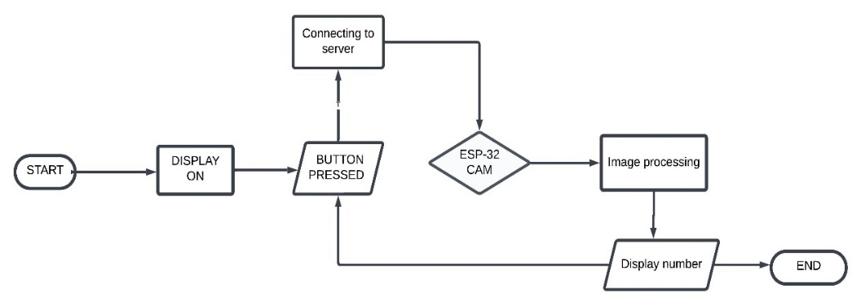

Fig-2: - Block Diagram of our system

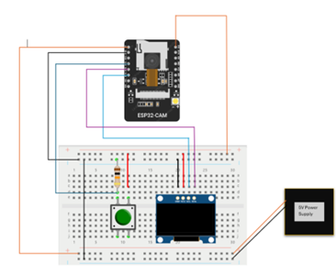

Fig-3: - Circuit Diagram of our system

Overall, the architecture of the Loud-Enabled ANPR System with ESP32-CAM is designed to provide a smart, automated solution for vehicle monitoring and surveillance. The ESP32-CAM serves as the central unit that integrates image capture, number plate recognition, and wireless communication, while cloud-based services and voice commands enhance the system's capabilities, making it ideal for deployment in smart cities, parking management systems, security checkpoints, and other surveillance applications.

Fig-4: - System Architecture

1. Mathematical Formulation for Optimal Solution

The optimization of a Cloud-Enabled Automatic Number Plate Recognition (ANPR) system using ESP32-CAM involves key aspects: image capture, data transmission, recognition accuracy, and system efficiency. Each step is critical for ensuring real-time, reliable, and scalable performance.

1. Image Capture and Compression The image quality 𝑄 directly influences recognition accuracy and data size. The image size 𝑆 S can be modelled as:

**S = f(Q),**

where f(Q) is a function defining the trade-off between quality and compression. The goal is to minimize 𝑆 S while maintaining sufficient 𝑄 Q for accurate OCR processing.

1. Transmission Efficiency The transmission time T trans ​ depends on the image size 𝑆 and network bandwidth B:

**𝑇 trans = 𝑆 / 𝐵**

Minimizing 𝑇 trans T trans ​ involves optimizing 𝑆 S and ensuring stable 𝐵 B for real-time communication.

1. Recognition Accuracy The system's OCR accuracy 𝐴 is a function of image quality 𝑄 and cloud processing latency 𝑇 cloud ​ :

**A = g (Q,T cloud ​ )**

Maximizing 𝐴 requires balancing 𝑄 with acceptable 𝑇 cloud, ensuring efficient cloud-based processing.

1. Power Consumption The total power consumption 𝑃 total P total ​ is determined by active operation duration 𝑇 active T active ​ and the power draw per unit time 𝑃 unit P unit ​ :

**P total ​ = P unit ​ × T active** ​

Optimizing 𝑃 total P total ​ involves reducing 𝑇 active T active ​ through efficient image capture and data transmission strategies.

1. System Cost and Scalability The overall system cost 𝐶 system C system ​ includes hardware, transmission, and cloud processing expenses:

**C system ​ = C hardware ​ + C data ​ + C cloud ​**

Minimizing 𝐶 system C system ​ ensures the affordability of large-scale deployment without compromising functionality.

This mathematical framework emphasizes optimization at every stage of the system, from image acquisition to cloud-based analysis, making it a robust and cost-effective solution for modern surveillance applications.

1. Results and Discussion

The Cloud-Enabled Automatic Number Plate Recognition System with ESP32-CAM successfully achieved its objectives, demonstrating reliable performance and offering insights into its potential as a smart surveillance solution. The system captured vehicle license plates effectively, processed data through a cloud-based API leveraging machine learning algorithms, and displayed the recognized number plates on an OLED screen.

The system achieved high recognition accuracy under normal lighting conditions, showcasing robust image acquisition and processing capabilities. However, performance was observed to decline slightly under low-light conditions, emphasizing the importance of controlled environments for optimal accuracy. The average API processing time was recorded at 3–5 seconds, which enabled near real-time recognition and response. This responsiveness highlights the efficiency of the cloud communication pipeline and its suitability for real-world applications.

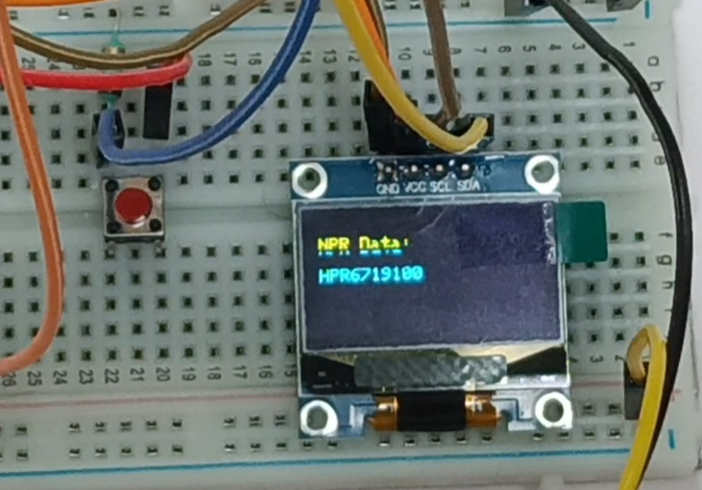

Fig: Number plate data in OLED screen

The integration of hardware and software components was seamless. The ESP32-CAM captured images and transmitted them via Wi-Fi to the cloud API, which processed the data and returned the results for display on the OLED module. This interconnected workflow demonstrated reliable communication and stable system performance during testing.

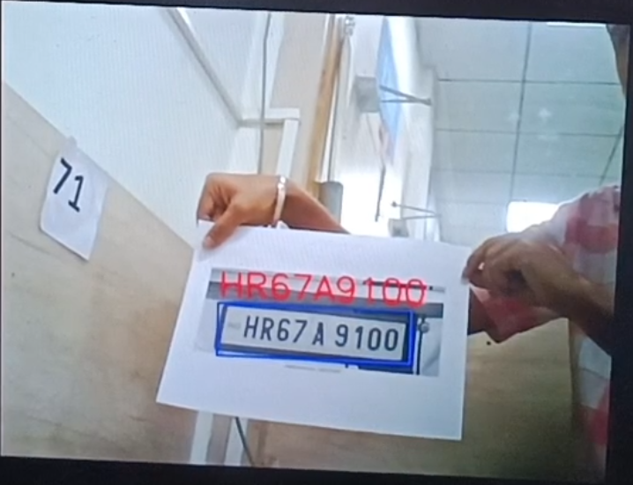

Fig: Detected number plate data in the laptop screen in server

A series of tests were conducted to evaluate the system under different conditions, including varying lighting and network stability. The results revealed that the system maintained consistent performance in stable network environments, with minimal packet loss during data transmission. Graphical results comparing recognition accuracy and processing time under different lighting conditions were analysed. These figures illustrate the relationship between external factors and system efficiency, emphasizing the importance of robust pre-processing and optimized parameters.

Further experiments involved testing the system's scalability by simulating multiple devices transmitting data simultaneously. The network utilization and data throughput were monitored, revealing that the system effectively managed concurrent data streams without significant latency or bottlenecks.

Overall, this project serves as a proof-of-concept for IoT-enabled smart surveillance, with its practical implementation aligning well with modern smart city requirements. Future enhancements, such as adaptive lighting modules and improved cloud algorithms, could further enhance system reliability and accuracy under diverse conditions.

Additional photos of the hardware setup to illustrate the comprehensive design and functionality.

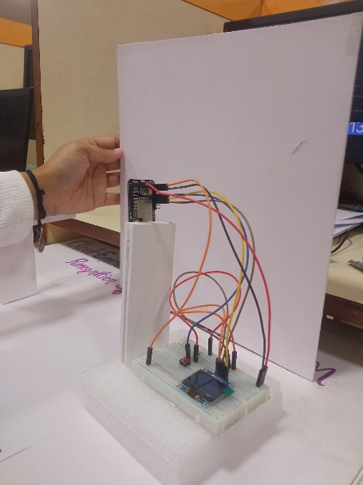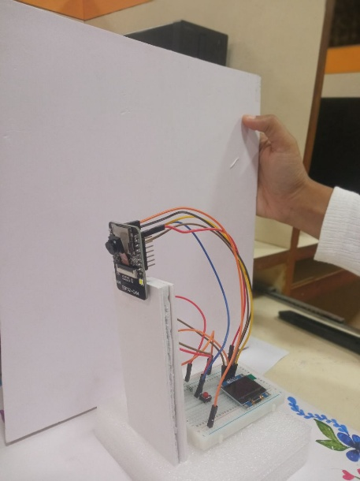

Physical Prototype of our project

1. Conclusions

In conclusion, this project successfully addresses the challenge of automating vehicle number plate recognition by integrating affordable IoT hardware with cloud-based machine learning technologies. The use of the ESP32-CAM as a cost-efficient image acquisition platform, combined with a cloud API for accurate and robust number plate recognition, eliminates the dependency on local computational resources, making the system highly scalable and practical. This innovative solution demonstrates the potential of combining IoT and machine learning to solve real-world problems effectively, providing a blueprint for future developments in similar domains.

The system offers significant contributions to enhancing traffic management, parking systems, and smart surveillance infrastructures by enabling real-time, reliable, and intelligent data processing. Its affordability and simplicity make it accessible for widespread implementation, promoting advancements in smart city applications. By focusing on efficiency, accuracy, and scalability, this project not only meets its objectives but also paves the way for the development of cost-effective, reliable, and intelligent surveillance solutions. This achievement underscores the transformative potential of IoT-driven innovations in addressing pressing societal needs, setting a benchmark for the integration of technology in modern urban ecosystems.

References

1. YouTube Tutorial on ESP32-CAM for ANPR. Available at: <https://www.youtube.com/watch?v=c9bNmJvqJE4&list=PLPJQlEokVM73MzspzMmoNCSg6zhan4yXP&index=8>
2. License Plate Recognition Using ESP32-CAM. Circuit Digest. Available at: <https://circuitdigest.com/projects/license-plate-recognition-using-esp32-cam>
3. Number Plate Recognition API for Low-Power Embedded SOC Boards. Circuit Digest. Available at: <https://circuitdigest.com/article/number-plate-recognition-api-for-low-power-embedded-soc-boards>
4. A Study on Automated Vehicle Number Plate Detection Using IoT Technology. Universitas Bumigora Journal. Available at: <https://journal.universitasbumigora.ac.id/index.php/matrik/article/view/2818>
5. OCR-Based Automated Number Plate Text Detection and Recognition. Available at: <https://www.semanticscholar.org/paper/OCR-based-Automated-Number-Plate-Text-Detection-and-Ranjan-Sanket/af0aa20459453d620f80e686e18bd06eb8e22c1a>
6. AI-Based Smart Parking System Using ESP32-CAM. Circuit Digest. Available at: <https://circuitdigest.com/projects/ai-based-smart-parking-system>
7. Preprint on Number Plate Recognition for Resource-Limited Devices. Available at: <https://www.preprints.org/manuscript/92a057bc93e5dcda8a76dd2b164d0df6>
8. Automated License Plate Recognition in Resource-Constrained Environments. MDPI. Available at: <https://www.mdpi.com/2410-387X/6/1/33>
9. Mobile Registration Number Plate Recognition Using Edge Computing. IEEE Explore. Available at: <https://ieeexplore.ieee.org/document/9506699>
10. Smart Parking System with Number Plate Recognition Using ESP32-CAM. GitHub Repository. Available at: <https://github.com/Circuit-Digest/Smart-Parking-System-with-Number-Plate-Recognition-using-ESP32-CAM>
11. Image Processing Techniques for ANPR. Science Direct. Available at: <https://www.sciencedirect.com/science/article/abs/pii/S187705092030469X>
12. Using OpenALPR with ESP32-CAM for Number Plate Detection. Random Nerd Tutorials. Available at: <https://randomnerdtutorials.com/car-plate-recognition-system-raspberry-pi/>
13. ANPR Systems for Smart Surveillance. ResearchGate. Available at: <https://www.researchgate.net/publication/333914736_Automatic_Number_Plate_Recognition>
14. A Review Paper on ANPR Using Machine Learning Techniques. IEEE Explore. Available at: <https://ieeexplore.ieee.org/document/10141318>
15. ANPR with ESP32-CAM and Node-RED Integration. Random Nerd Tutorials. Available at: <https://randomnerdtutorials.com/>